**APPLICATION DEVELOPMENT FOR FINDING FLATMATES**

**COMPETITION AND INDUSTRY**

In terms of every service there are two parts, one provides the service and one receives. Likewise in our Service, there are also two sides. In various countries, it's very expensive to have a flat alone. In this case, the age group 18-30 has faced most problems because of its expense. So Flat is a service where anyone can share their preferred place with someone you like within your budget. The most important part is to find someone trustworthy for this shared accommodation service. This research tries to explore how we can help the user with easy navigation with clean interfaces and experiences as usual.

Living alone in an apartment creates a lack of interest and difficulty in living. A student who left their homes and shift to a big and unknown city to achieve their aim, see depression and herculean of living away and alone. They just keep living with a question – HOW TO FIND A ROOMMATE IN A NEW CITY?

However, living with someone is not as easy as it seems to be. Two people who are living together may have different likings, a misbalance of income, dissimilar backgrounds, and many more things. Especially money plays an important cause behind the disinterest of the people likely to be lived together. According to a survey, more than one out of five, faces a horrible situation in sharing their spaces with someone without having a prior awareness of their financial conditions.

So it is better to have discussions or a clear way to keep things sorted before signing the rental agreement to prevent any misunderstanding later. So in this context, having the best roommate finder app is important when looking to find someone for living with. Yes, there are pros to living with someone vulnerable but sharing comfort talks with your roommate and costs help in growing the relationship and fixing the issue who could not afford the expensive living. One positive study reveals that sharing your space and thoughts is a key to your mood and health. People who have no families with them in a strange city, prefer to stay at their offices and take on some extra projects just to avoid home memories.

Facts about the Rental Industry

In India about 68% of people are likely to prefer rented accommodations. As per a survey of tenant stay period retention in India, the co-living and sharing market is expected to grow double by 2024. This is a positive raise in the co-living spaces and it is expected to be more. While the spaces have significant growth in consumer outreach facilitated with the basic and advanced amenities like gym, lounge, pools that give them comfort under the budget.

However, 60% of the people shattered and opt to leave out the idea of co-living because of the unsupportive behaviour of their roommates. Taking this fact into the advantage you can contribute with a realm roomie finder app development to throw a spark into the shared living market. Your generous app for finding roommates would help people to eliminate their roommate trauma. Apps like Roomie and Codee are platforms that connect people with the same preference and like minds. So now you can connect with the people who can walk and go well with you.

**COMPETITIVE ANALYSIS**

To observe the existing roommate-seeking and house-sharing platforms, I selected some direct competitors: Roomi, Roomaters,

SpareRoom and Roomster.

1. ROOMI

[Roomi](https://roomiapp.com/) works its magic by putting two matches together after you answer questions about yourself and what you're searching for in an ideal roommate. Roomi utilizes an algorithm to pair you with a roommate who is a good fit for you.

Roomi allows users to do fast background checks and connect social media accounts, allowing both roommates to feel more assured and safe during the process. You can message possible roommates through this roommate finder app when you're ready!

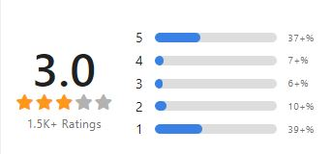

2. ROOMATERS

[Roomaters](https://roomaters.com/) looks for a roommate based on more than just your tastes. Users complete a personality test to aid in the matching of possible roommates.

You'll be able to provide information about your interests, hobbies, and what sort of roommate you are (social, introverted, messy, neat freak, etc.). So, whether you like music, painting, rock climbing, or superhero movies, you'll be able to discover someone you'll get along with.

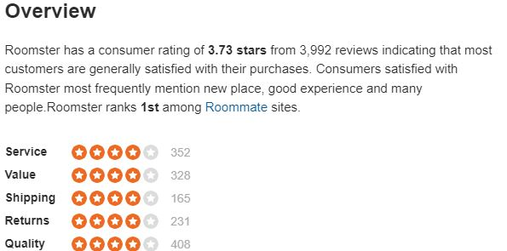

3. SPAREROOM

[SpareRoom](https://www.spareroom.com/roommates) claims to be the busiest roommate app on the market, with a roommate match being made every three minutes. SpareRoom stands out from other roommate apps because it employs a staff of people to check each ad, ensuring that all postings are secure and genuine.

This app even offers speed roommate events where you can meet individuals in your neighbourhood through a speed dating-style situation to see if you can find someone with whom you get along.

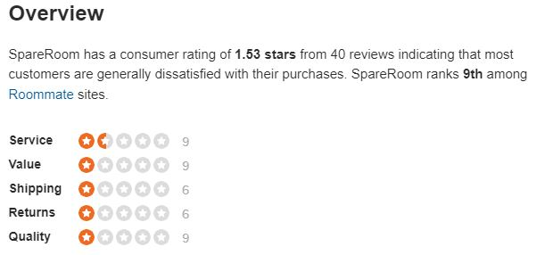

4. ROOMSTER

[Roomster](https://www.roomster.com/) now provides listings in 192 countries and 18 languages. It matches you with possible roommates based on personality factors, keyword searches, and shared hobbies. Members can find a match based on friend recommendations, hobbies, interests, and questions answered in their profiles. Because Roomster allows users to link their social media accounts, this app has more information to help users discover the right match. Once you've found a possible roommate who appears to be a good fit, you may contact them using the Roomster mailbox.

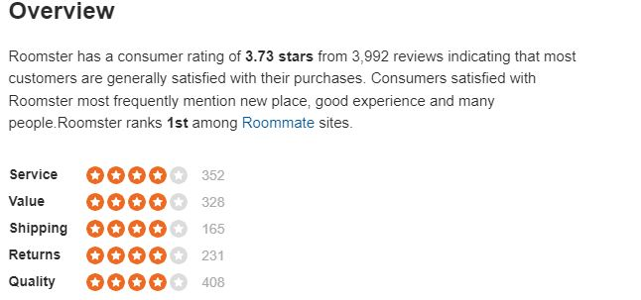

**INDUSTRIAL ANALYSIS**

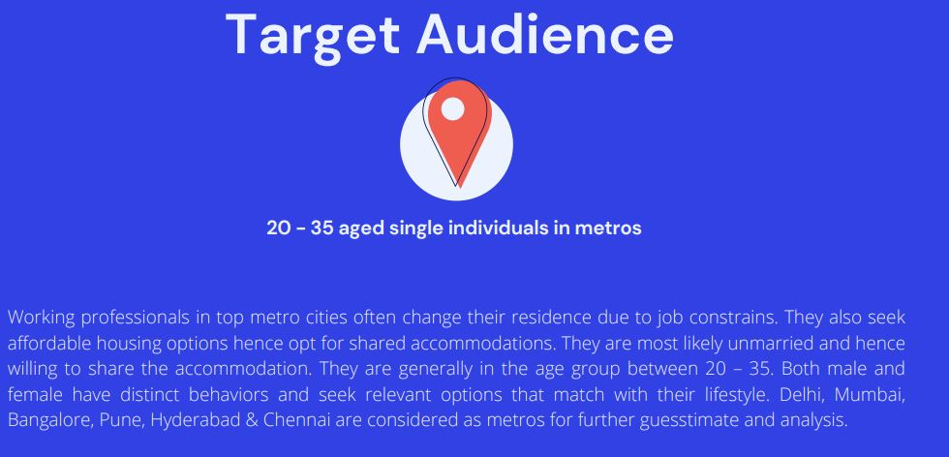

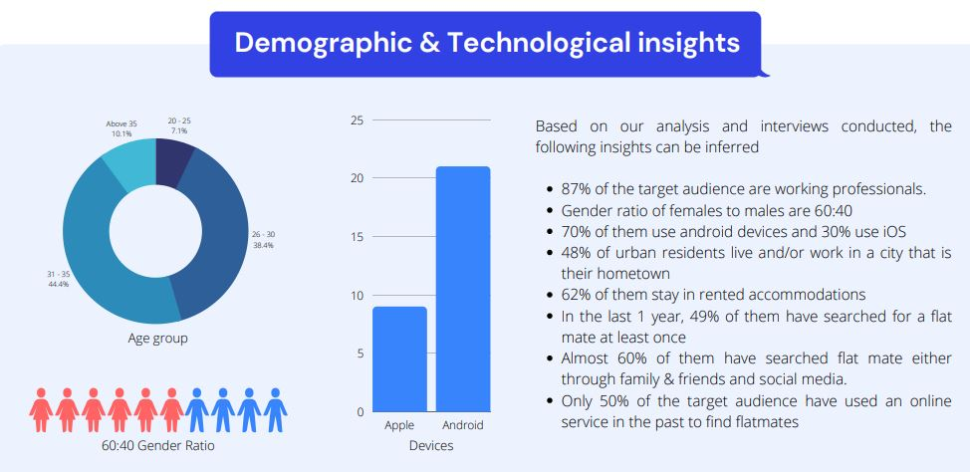

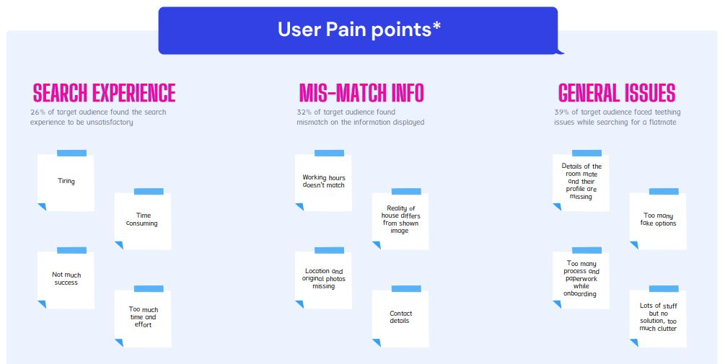

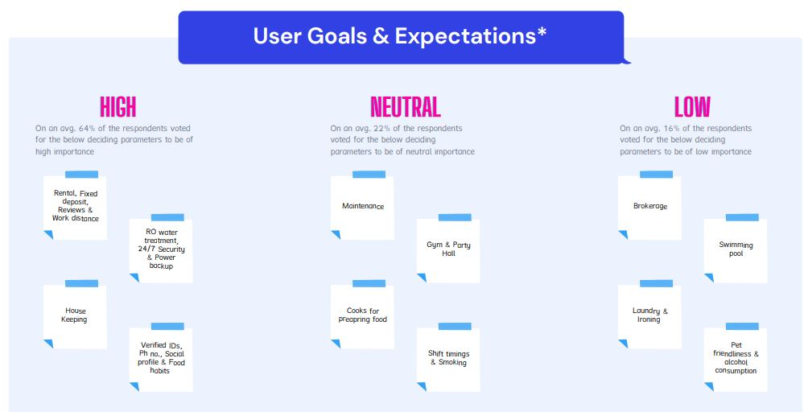

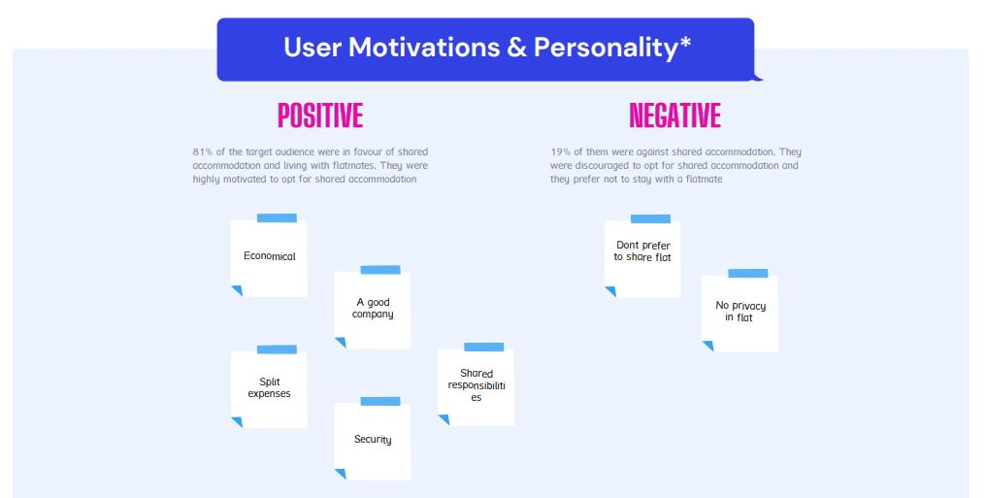

**REPORT CREATED BY**

**FAHAD IQBAL SHAH**

**PRODUCT MANAGEMENT INTERN**

**NOVO CABS**